Christy Ring
Nicholas Christopher Michael "Christy" Ring was an Irish hurler whose league and championship career with the Cork senior team spanned twenty-four years from 1939 to 1963.

Early life
Christy Ring was born on the 12 of October 1920.
He had two brothers, Willie John and Paddy Joe, and two sisters — Katie and Mary Agnes. His family later moved to Cloyne where they occupied a house on Spit Lane.
Christy Ring was educated at the local national school in Cloyne, where he was noted as a quiet but diligent pupil. On one occasion, the school master, Maurice Spillane, offered a prize of a hurl and sliotar to the boy who would get the highest grade in the school.
Ring was just twelve years-old when he played in his first minor game for Cloyne. Playing in goal he received a baptism of fire against Sarsfields. Two years later he was at right wing-forward and claimed his first medal when Cloyne won the annual Glenbower tournament.
Ring first played competitive hurling following encouragement his local national school teachers Michael O'Brien and Jerry Moynihan. He first appeared on the Cloyne minor team at the age of twelve before later winning a county.

Job
Christy Ring’s job was an oil tank driver.

MINOR HURLING
He won a county minor championship medal in this grade in 1938 following a 5–3 to 4–0 win over the Seán Clárach's club from Charleville.

Family
Christy ring’s wife is called Rita Ring.
Christy Ring had two children Christy and Mary.
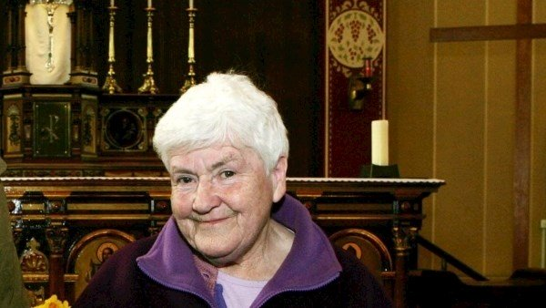

Hurling for his county
Christy Ring played for county Cork.
Ring has 65 appearances for Cork.
Ring scored a tally 33-208 for his county.
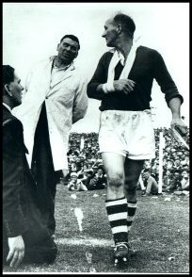
Inter-county titles
Munster titles 9
All-Irelands 8
NHL 4
Ring is widely regarded as the greatest hurler in the history of the game, with many former players, commentators and fans rating him as the number one player of all time.
Died 2 March 1979 (aged 58)
Morrison's Island, Cork, Ireland
Height 5 ft 8 in (173 cm)
Nickname Ringey

The Christy Ring cup
The Christy Ring Cup, which was introduced in 2005, replaced the All-Ireland B Hurling Championship (1974-2004). Between 2005 and 2017 the Christy Ring Cup was the second tier hurling championship. With the introduction of the Joe McDonagh cup, the Christy Ring Cup is the highest tier of the championship system without direct entry to that year's All-Ireland finals series (the top two teams in the Joe McDonagh Cup gain entry to preliminary quarter-finals).
Last year’s winner of the Christy Ring cup was county Meath.

