Galway

1. Galway City is the third largest city in the Republic of Ireland (a population of 75,414).
2. Galway City is nicknamed “The City of Tribes”.
3. The Claddagh Ring is Galway’s own symbol of love, loyalty and friendship, worn the world over.
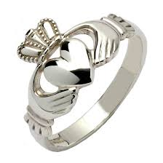
4. The city is known for its numerous festivals, celebrations and events, including the Galway Arts Festival and parade, during the summer, which is known all over the world.
5. Galway is the European capital of culture this year 2020.
6. There are 7,000 Irish speakers in Galway city, which is nearly ten percent of the population.
7. Galway is often referred to as the “Cultural Heart of Ireland” as it is most associated with the Irish language, music, song and dance traditions.
8. Eyre Square is a famous park in the centre of Galway. There is a famous statue in Eyre Square called Padraic O Conaire statue.
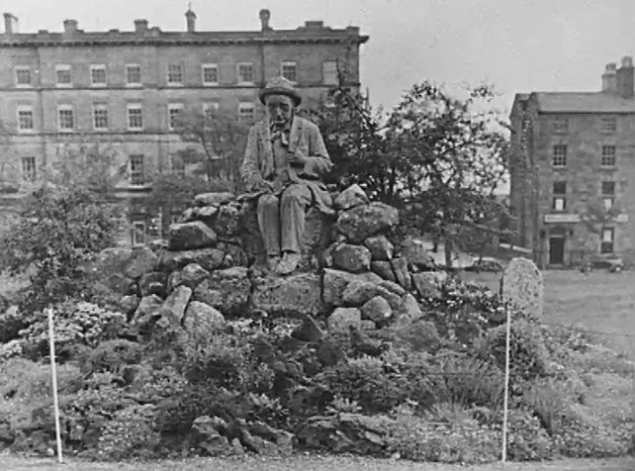

9. The Galway GAA stadium is called the Pearse Stadium.
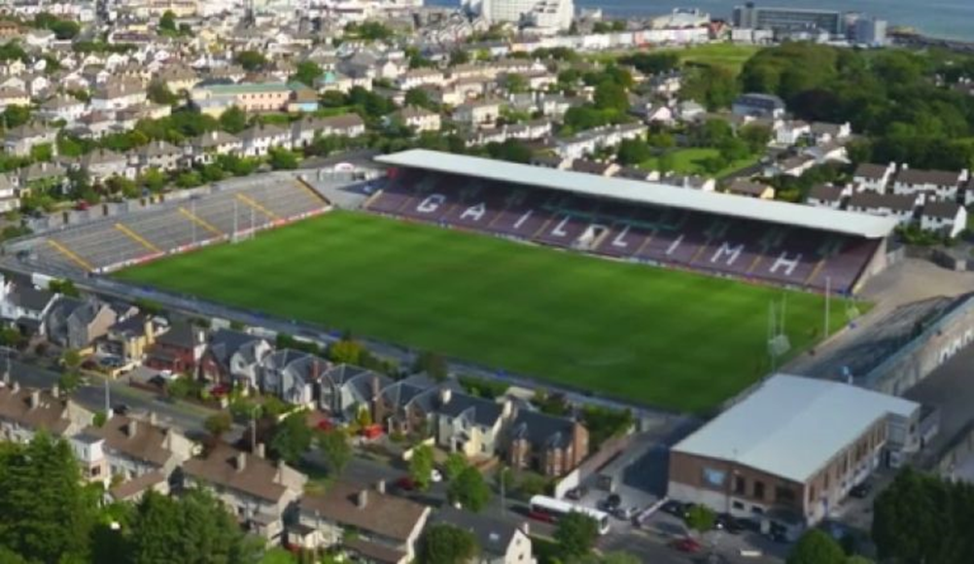

Physical Features
Twelve Bens mountain range in the Connemara National Park in Galway.
Lough Corrib is a lake in the west of Ireland. It is the largest lake within the Republic of Ireland.
The River Corrib connects the lake to the sea at Galway.

Galway GAA
Football (Inter-County)
All-Ireland Senior Football: (9) 1925, 1934, 1938, 1956, 1964, 1965, 1966, 1998, 2001
National Football League: (4) 1940, 1957, 1965, 1981
Hurling (Inter-County)
All-Ireland Senior Hurling: (5) 1923, 1980, 1987, 1988, 2017,
National Hurling League: (9) 1932, 1951, 1975, 1987, 1989, 1996, 2000, 2004, 2010
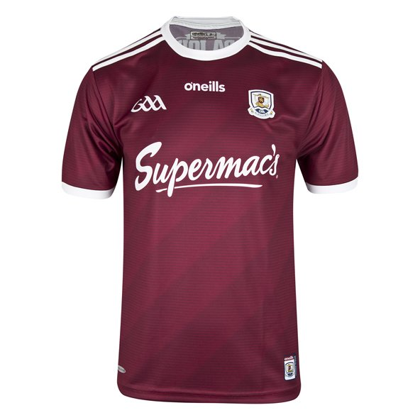
Galway’s hurling team is 1. Colm Callahan 2. Jack Grealish 3. Daithi Burke 4. Aidan Harte 5. Padraic Mannion 6. Gearoid McInerney 7. Kevin Hussy 8 . Johnny Coen 9 . David Burke 10. Cathal Mannion 11 . Niall Burke 12. Jason Flynn 13. Conor Whelan 14. Conor Cooney 15. Brianon Concann
Galway team football is 1. Connor Gleeson 2. Sean Kelly 3. Sean Mulkerrin 4. Johnny Heaney 5. Liam Silke 6. John Daly 7. Cillian McDaid 8. Ronan Steede 9. Tom Flynn 10. Eamon Brannigan 11. Damien Comer 12. Michael Daly 13. Martin Farragher 14. Shane Walsh 15. Adrian Varled’s
Previous Galway v Meath league meetings:
2017 – Meath 1-13 Galway 0-15 2016 – Galway 0-15 Meath 1-12 2015 – Galway 2-13 Meath 1-12 2014 – Meath 3-18 Galway 4-11 2012 – Galway 1-12 Meath 1-11

