Newgrange
Newgrange was built around 3,200 BC. Newgrange was "rediscovered" in 1699 by Charles Campbell. Newgrange is built out of grass and three different types of stone. Stone Age farmers built the Newgrange. Newgrange is located in Donore, Co. Meath 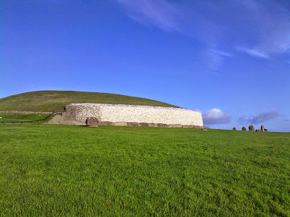

What is in Newgrange?
In the centre of the monastery there is a passage tomb full of bones and name’s carved on the wall there are no bones in there anymore because they turned it in to a tourist attraction so they had to take them out. Newgrange is 4,047 m² long. Newgrange gets light through the roof box at the top of the entrance.

What is the winter solstice?
The winter solstice, hiemal solstice or hibernal solstice, also known as midwinter, occurs when one of the Earth's poles has its maximum tilt away from the Sun. It happens twice yearly, once in each hemisphere (Northern and Southern). For that hemisphere, the winter solstice is the day with the shortest period of daylight and longest night of the year, when the Sun is at its lowest daily maximum elevation in the sky. At the pole, there is continuous darkness or twilight around the winter solstice. Its opposite is the summer solstice.

Newgrange visitor centre
Access to Newgrange is through the Brú Na Bóinne Visitors' Centre at nearby Donore, just across the river Boyne. In recent times, there have been as many as 200,000 visitors to Newgrange each year, making it the most visited archaeological monument in Ireland.
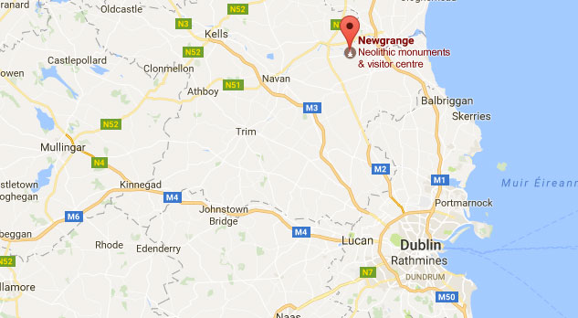

Why don’t you come and visit.

